TABLE OF CONTENT
CHAPTER NO. TITLE PAGE NO.
1. INTRODUCTION 4 - 6
1.1 PURPOSE OF THIS PROJECT
1.2 OVERIVEW OF CHATNEST APPLICATION.
1.3 PROBLEM STATEMENT
1.4 OBJETIVE OF THE PROJECT
1.5 SCOPE OF THE PROJECT
1.6 MOTIVATION OF THE PROJECT
1.7 FEATURE OF CHATNEST

2. LITERATURE SURVEY SUMMARY 7 - 8
2.1 EVOLUTION OF COMMUNICATION
SYSTEMS

2.2 TRADITIONAL WEB COMMUNICATION
METHODS

2.3 INTRODUCTION OF REAL-TIME WEB
TECHNOLOGIES

2.4 MERN STACK AS A MODERN WEBSITE
FRAMEWORK

2.5 DATA SECURITY AND ENCRYPTION IN CHAT
APPLICATIONS

2.6 VOICE AND AUDIO FEATURES IN
COMMUNICATION TOOLS

3. PROPOSED SYSTEM 9 - 12
3.1 INTRODUCTION…………………………………………..
3.2 SYSTEM OVERVIEW……………………………………..
3.3 PROPOSED METHODOLOGY……………………………
3.4 KEY FEATURES IMPLEMENTED………………………..
3.5 ADVANTAGES OF THE SYSTEM………………………..

4. SYSTEM DESIGN 13 - 15
4.1 INTRODUTION……………………………………………..
4.2 FLOWCHAT DIAGRAM………………………………………
4.3 SYSTEM ARCHITECTURE DIAGRAM……………………
4.4 DATA FLOW DIAGRAM……………………………………
4.5 ENTITY RELATIONSHIP DIAGRAM………………………
4.6 USE CASE DIAGRAM……………………………………….
4.7 SEQUENCE DIAGRAM………………………………………

5. SYSTEM IMPLEMENTATION 16 - 90
5.1 INTRODUCTION………………………………………………..
5.2 TECHNOLOGIES USED………………………………………...
5.3 BACKEND IMPLEMENTATION………………………………..
5.4 FRONTEND IMPLEMENTATION………………………………
5.5 ENCRYPTION AND AUTHENTICATION………………………
5.6 IMPLEMENTATION OF VOICE TYPING AND
AUDIO RECODER………………………………………………
5.7 IMPLEMENTATION OF FILE SHARING………………………
5.8 ONLINE USER TRACKING LOGIN……………………………

6. RESULT AND TESTING 91 - 92
6.1 INTRODUCTION…………………………………………………..
6.2 TEST CASES AND SCENARIOS…………………………………

7. SUMMARY 93
8. REFERENCES 93

INTRODUCTION

1.1 Purpose of this project:
- The project aims to create a real-time messaging system where users can interact instantly, like the experience offered by leading chat applications.
- The project serves as a learning experience for implementing MongoDB, Express, React, and Node.js together in a complete full-stack environment.
- A major purpose is to understand how real-time communication works through WebSocket and how Socket.io manages live message transfers.
- The project focuses on ensuring safe and encrypted conversation, so that user data and private chats remain protected.
- The aim is not just to build a chat app but to integrate modern features such as file sharing, voice typing, and audio recording to enhance usability.
1.2 Overview of ChatNest:
- Built using the MERN stack, it allows users to communicate instantly through a fast and responsive interface.
- The system stores user credentials in encrypted format, ensuring privacy and preventing unauthorized access.
- Every message appears in real-time without refreshing the page, giving a smooth chatting experience.
- Users can exchange images, MP4 videos, documents, and even audio recordings directly within the chat window.
- ChatNest includes multiple theme options, including dark and light mode, so users can personalize their chatting environment.
1.3 Problem Statement:
- Many existing chat applications are complex and closed-source, making it hard for students to understand how they function internally.
- Users often rely on third-party apps where they have limited control over privacy and interface personalization.
- Many platforms fail to provide easy access to voice typing, audio messages, and media sharing in one place.
- Students require hands-on, real-world projects to understand REST APIs, encryption methods, and live communication systems.
- There is a need for a platform that balances performance, security, and usability while remaining easy to deploy and scale.
1.4 Objective of the project:
- The primary objective is to develop a platform that supports instant messaging with a smooth and responsive interface.
- The project aims to integrate encrypted login and registration systems using modern hashing techniques.
- Users should be able to share images, videos, documents, and audio recordings effortlessly.
- Voice typing, audio recording, and online user tracking are implemented to make conversations richer and more interactive.
- Another key objective is to gain hands-on experience with MERN stack, backend APIs, database design, and Socket.io.
1.5 Scope of the project:
- The project spans front-end UI development, backend API creation, database management, and real-time communication.
- ChatNest is designed for small to medium-scale usage, making it suitable for friend groups, classmates, or team discussions.
- Features like group chats, status updates, notifications, or end-to-end encryption can be added later.
- The app covers a wide scope of communication—text, voice, images, videos, and documents.
- With theme customization and a clean interface, the scope includes improving usability along with core functionality.
1.6 Motivation Behind the Project:
- The motivation came from wanting to know how apps like WhatsApp and Messenger deliver messages instantly.
- Building this project provides real exposure to full-stack development and enhances employable skills.
- Instead of creating a basic academic project, the goal was to develop a tool that people can use.
- As remote interactions increase, creating a secure and modern chat application becomes meaningful and relevant.
- The idea of adding voice typing, media sharing, and audio recording encouraged exploring new APIs and technologies.

1.7 Features of ChatNest:
- Messages appear immediately using Socket.io without any page reload.
- User credentials are encrypted and stored safely to protect privacy.
- Users can send images, MP4 videos, documents, and recorded audio messages.
- The app supports speech-to-text conversion and allows users to record and send audio clips.
- Multiple color themes and modes help users personalize the interface based on their preference.
- Users can see who is currently active, enhancing awareness of communication.
- Text messages, files, and audio recordings can be quickly searched using keywords.
1.8 Organization of the Report:
- Covers the purpose, problem statement, objectives, scope, motivation, and overall concept of the project.
- Discusses existing systems, communication technologies, and the need for ChatNest.
- Explains functional and non-functional requirements, feasibility study, and system design considerations.
- Includes architecture diagrams, database schema, data flow diagrams, and UI structure.
- Describes technologies used, backend APIs, frontend structure, and real-time socket implementation.
1.9 Summary:
This chapter introduces ChatNest, outlining its purpose, objectives, and key features. It highlights the motivation, problem statement, and overall scope of the project, offering a clear understanding of why ChatNest was developed and how it aims to enhance secure, real-time communication through modern web technologies.

LITERATURE SURVEY SUMMARY:
Evolution of Communication Systems:
- Earlier communication systems were based on emails and static message boards, which lacked instant interaction.
- The need for real-time, instant communication led to the rise of chat applications such as WhatsApp, Messenger, and Slack.
- These platforms demonstrated the importance of low-latency communication, data synchronization, and secure message transfer.

Traditional Web Communication Methods:
- Initially, communication between client and server was done through HTTP requests, which required refreshing the page for every new message.
- This approach caused delays and poor user experience in chat-based systems.
- The introduction of AJAX (Asynchronous JavaScript and XML) improved this process by enabling data exchange without full-page reloads, but it still wasn’t truly real-time.

Introduction of Real-Time Web Technologies:
- The emergence of WebSocket revolutionized web communication by allowing two-way, persistent connections between clients and servers.
- Libraries like Socket.io built on top of WebSocket simplified implementation and made real-time chat applications more accessible to developers.
- This advancement enabled the creation of instant messaging systems, live notifications, and online presence tracking.

MERN Stack as a Modern Web Development Framework:
- The MERN stack (MongoDB, Express.js, React.js, Node.js) became popular for building scalable and efficient web applications.
- Express.js and Node.js manage backend logic, API routing, and server-side communication efficiently.
- React.js ensures a dynamic and responsive front-end user interface, enhancing usability and interactivity.

Data Security and Encryption in Chat Applications:
- As online communication grows, data privacy and security have become critical concerns.
- Research emphasizes the use of encryption algorithms (like AES or bcrypt hashing) to protect user credentials and sensitive data.
- Modern chat systems integrate end-to-end encryption and secure authentication methods (e.g., JWT tokens) to ensure message confidentiality and data integrity.
Voice and Audio Features in Communication Tools:
- Recent chat applications are incorporating voice typing (speech-to-text) and audio messaging to enhance accessibility and user experience.
- This innovation is supported by Web Speech API, Media Recorder API, and audio streaming libraries that enable seamless voice interaction.
- ChatNest adopts these modern techniques to provide hands-free communication and multimedia-rich interaction.

PROPOSED SYSTEM

2.1 Introduction:
- Instead of building a simple messaging tool, the system focuses on creating a smooth and interactive communication experience.
- This allows the platform to support secure data operations while also providing instant message delivery without waiting or page reloads.
- Every feature—from messaging to themes—is built to feel intuitive so that users can comfortably navigate the application.
- User credentials and chat data are stored in encrypted form to make sure privacy is never compromised.
- New functionalities such as group calls, chat bots, or advanced search can be added easily because of the flexible MERN architecture.
2.2 System Overview:
- The frontend is developed using React for a responsive interface, while the backend relies on Node.js and Express for secure data handling.
- This enables messages to be sent and received instantly, closely replicating the behavior of professional chat applications.
- All users, chat history, and file metadata are maintained in a structured and efficient manner.
- REST APIs handles login, registration, and media uploads, while Socket.io manages active conversations and online user updates.
- Files such as images, videos, and audio recordings can be shared effortlessly, giving complete communication experience.
2.3 Proposed Methodology:
- Each module—authentication, messaging, file handling, UI—is built separately to keep the system organized and easier to maintain.
- Functions such as login, registration, and chat history retrieval use API calls to ensure stability and security.
- A consistent real-time channel is established between clients and the server for instant message updates.
- All sensitive information is hashed or encrypted before being stored in the database, reducing security risks.
- The interface is kept simple, familiar, and customizable so that users feel comfortable while interacting with the app.
2.4 Key Features Implemented:
3.4.1 Real-time Messaging using Socket.io:
- Socket.io enables a continuous connection between users so messages appear the moment they are sent.
- Users can see when someone is typing or when a new message arrives immediately.
- Both clients and server can send updates, making the system more interactive.
- Instead of constant polling, the system only sends data when needed, reducing bandwidth usage.
- Real-time messaging makes conversations feel natural and uninterrupted.

3.4.2 Database Encryption in MongoDB:
- Even if the database is exposed, passwords remain unreadable due to hashing.
- Message content is stored in an encrypted format for better privacy protection.
- Even administrators cannot read user messages directly from the database.
- Encryption ensures that attackers cannot misuse stored credentials.
- Encryption aligns with industry standards for data protection in communication apps.

3.4.3 File Sharing (Images, MP4, Audio):
- Pictures load instantly, making conversations more expressive and interactive.
- Short videos or clips can be sent without switching to external apps.
- Voice notes or recorded audio clips make communication more flexible.
- File details such as name, type, and size are safely recorded in the database.
- The system handles file processing efficiently so users experience minimal delay.

3.4.4 Voice Typing and Audio Recording:
- Users can convert their speech into text, making messaging quicker and more convenient.
- This allows accurate and real-time speech recognition.
- When typing isn’t convenient, users can simply record their voice.
- Voice features help users with typing difficulties or slow typing speed.
- These advanced features bring the app closer to real industry-level chat systems.
3.4.5 Online User Tracking:
- Users can see which contacts are online, making communication more effective.
- Status updates are sent instantly whenever a user connects or disconnects.
- People are more likely to respond when they know the other person is online.
- Real-time status prevents users from waiting unnecessarily for replies.
- Online/offline badges make it easy to understand user availability.
3.4.6 Theme Customization and Dark Mode:
- This helps reduce eye strain and enhances readability in different lighting conditions.
- The system allows users to choose themes that match their preferences.
- Theme changes reflect instantly, giving a cohesive visual experience.
- Customizable interfaces make the application more enjoyable to use.
- Themes help create a polished and professional-looking interface.

2.5 Advantages of the Proposed System:
- Users experience smooth messaging without delays or reloads.
- Encryption ensures the safety of user data and private conversations.
- File sharing, images, videos, and audio make conversations more expressive.
- Voice typing, clean UI, and theme options create a comfortable user experience.
- The MERN stack allows the system to grow with additional advanced features.

2.6 Summary:
This chapter discussed the proposed system, outlining its structure, methodology, and main features. ChatNest’s combination of real-time messaging, encryption, and customization creates a secure and engaging chat experience. The next chapter will focus on system design and implementation details, explaining how each module works together to achieve seamless performance.

SYSTEM DESIGN
FLOWCHAT DIAGRAM
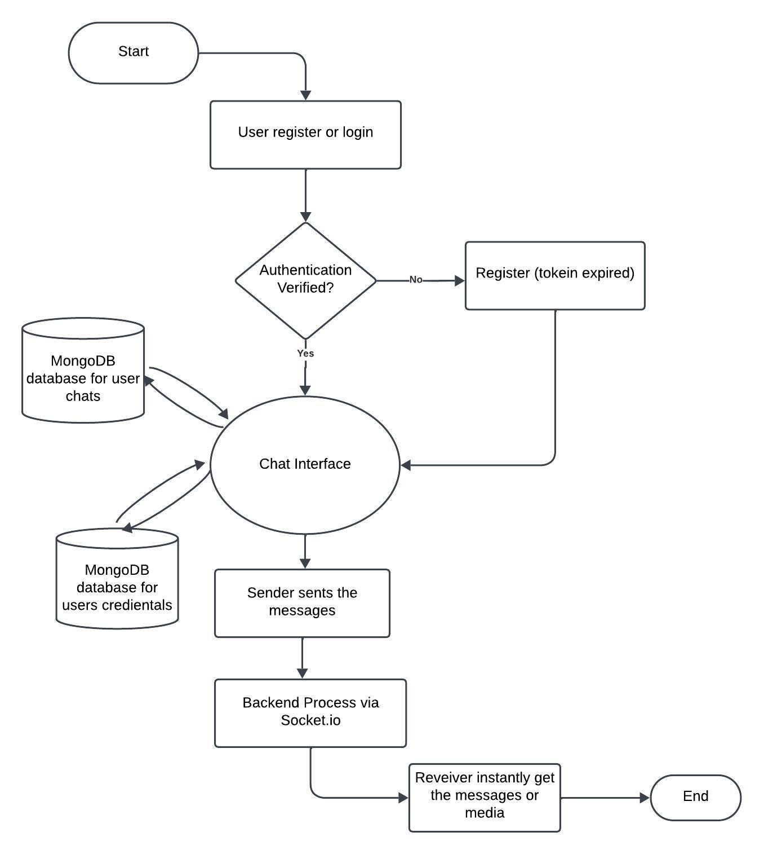
Figure-1
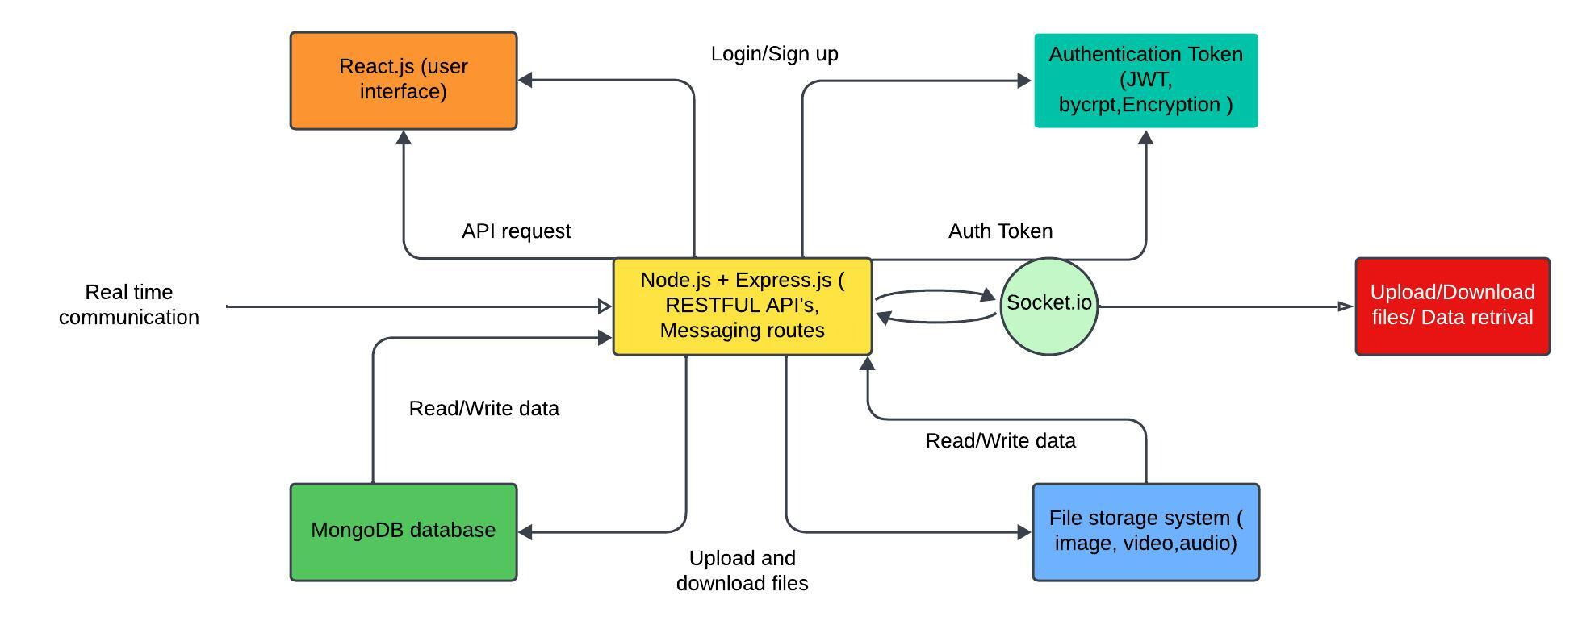
SYSTEM ARCHITECTURE DIAGRAM
Figure-2
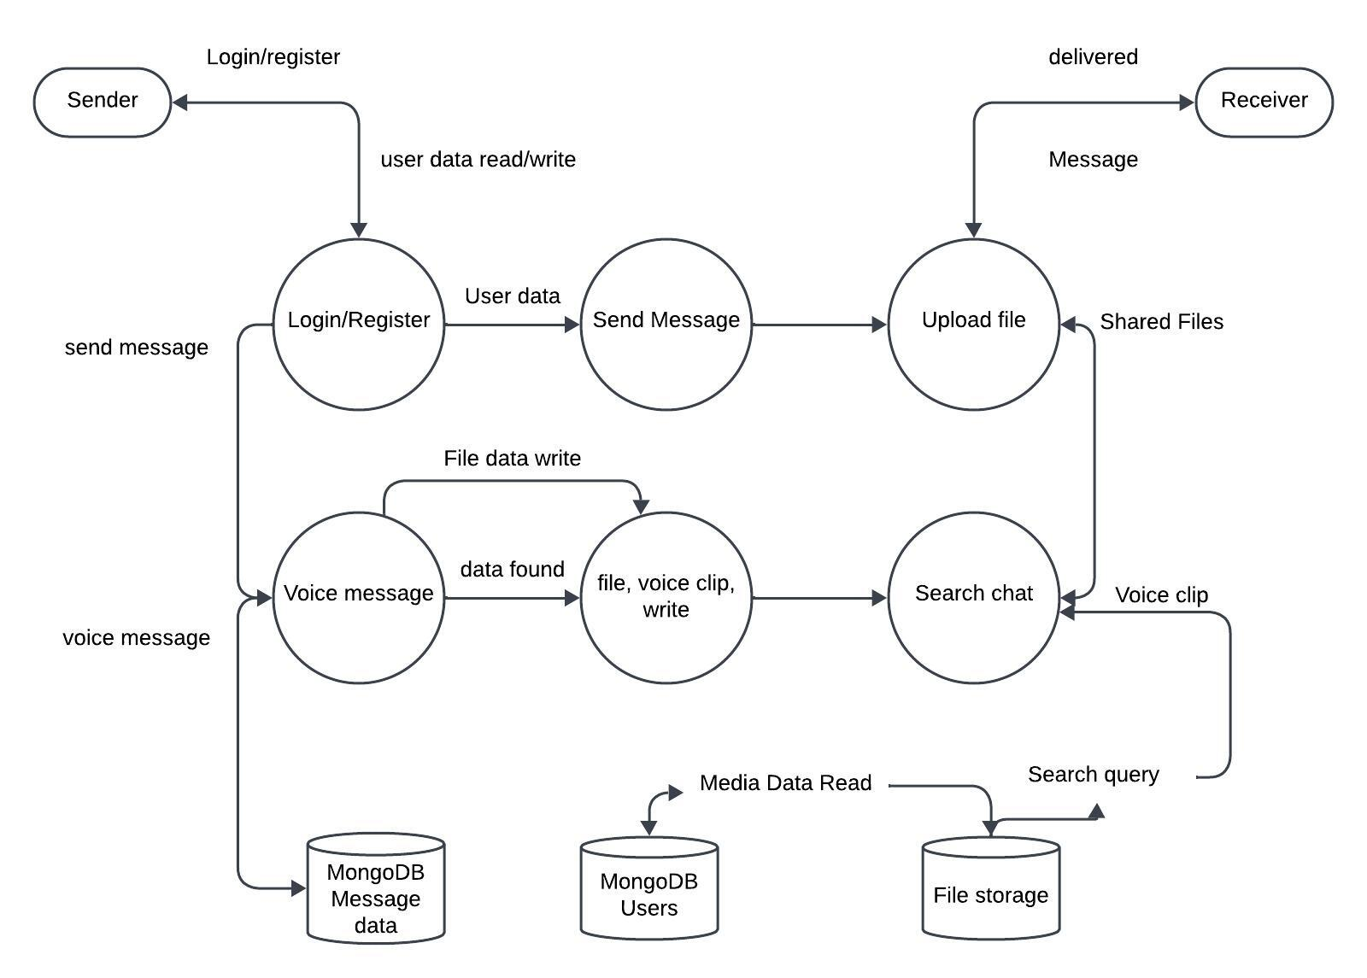
DATA FLOW DIAGRAM
Figure-3

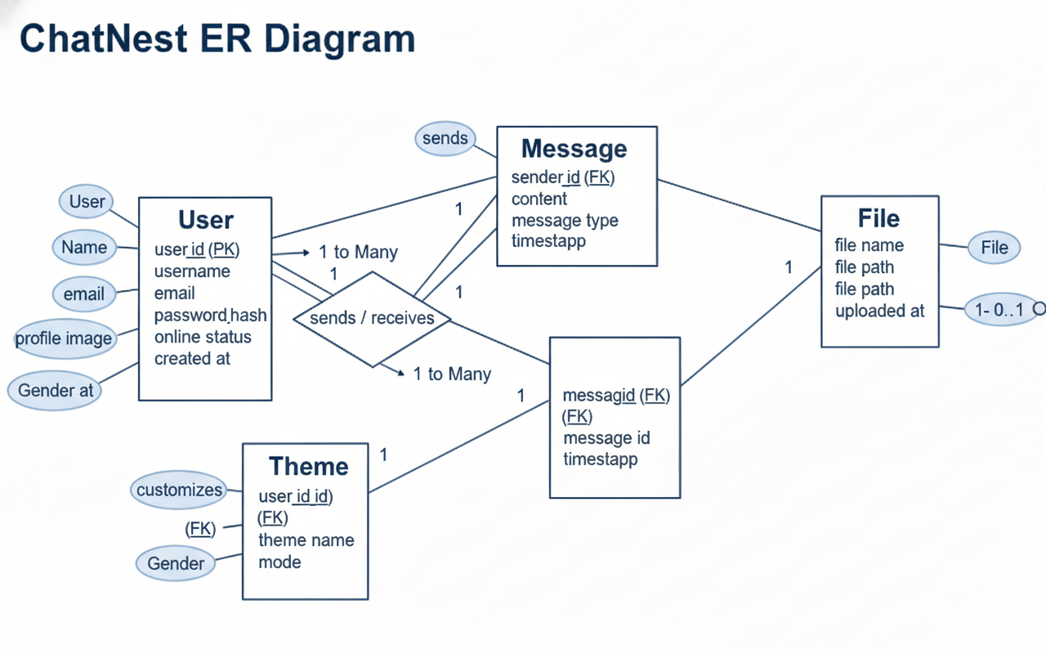
ENTITY RELATIONSHIP DIAGRAM
Figure-4
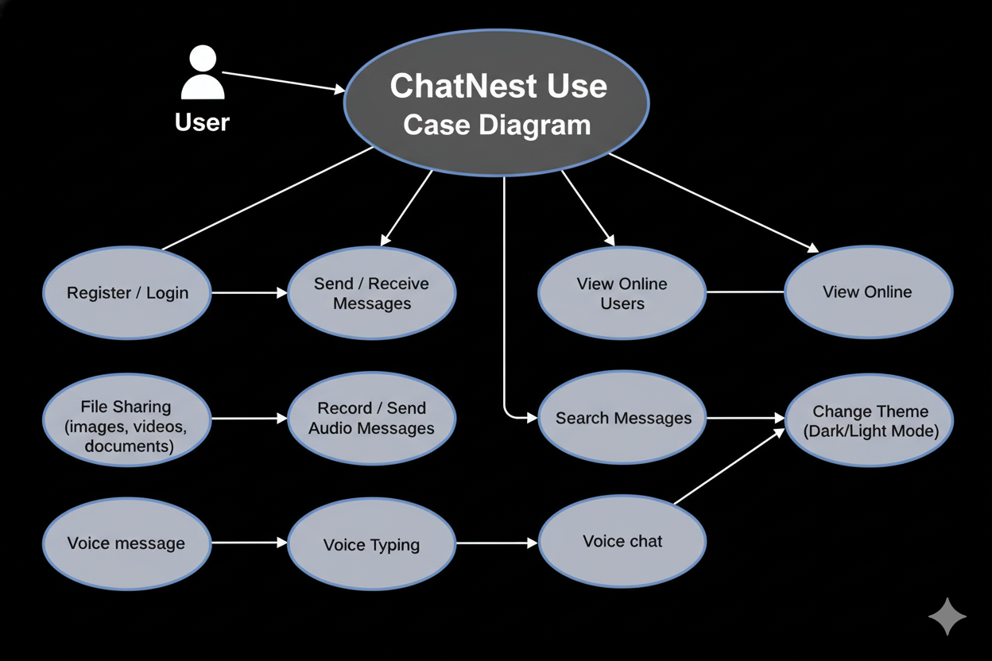
USE CASE DIAGRAM

Figure-5
SYSTEM IMPLEMENTATION
5.1 Introduction:
- After planning and designing the architecture, this stage focuses on the real coding and integration of all major modules.
- The chapter describes how both frontend and backend components were developed and connected.
- Whether it is messaging, authentication, or file sharing, every part is designed to run smoothly in real-world usage.
- Socket.io was carefully integrated to make conversations instant and uninterrupted.
- This ensures that the system is not just fast and interactive, but also trustworthy and safe for users.
5.2 Technologies Used (Mern Stack Overview):
ChatNest is built using the MERN stack—MongoDB, Express.js, React.js, and Node.js—combined with Socket.io for real-time communication. Each technology serves a specific purpose: React.js for interactive UI, Node.js and Express.js for backend logic, MongoDB for data storage, and Socket.io for instant message transfer. Together, these tools provide a robust, scalable, and responsive environment for modern web applications.

5.2.1 MongoDB:
- Its document-based structure makes storing chat conversations flexible and efficient.
- Each collection is optimized to ensure quick read and write operations.
- New features can be added without restructuring the entire database.
- Searching for messages or files becomes faster with properly created indexes.
- MongoDB handles frequent, small updates—which are common in chat apps—extremely well.

5.2.2 Express.js:
- It handles routes, API calls, and communication between the server and MongoDB.
- Middleware, route handlers, and controllers keep the code organized and readable.
- Express.js ensures the system responds quickly even under high usage.
- User login, registration, message saving, and file uploads are all built with Express routes.
- Express simplifies adding authentication, validation, and error handling.
5.2.3 React.js:
- It allows the application to update instantly when messages arrive or status changes.
- Each part—chat window, contact list, theme panel—is built as a separate component.
- Messages appear immediately without refreshing the page.
- React makes it easy to create a UI that looks good on both desktop and mobile screens.
- This helps in making the application more interactive and user-friendly.
5.2.4 Node.js:
- It handles client requests, socket connections, and database operations.
- The same language is used on both backend and frontend, simplifying development.
- Perfect for a chat application where many users may be active at the same time.
- Node’s non-blocking nature ensures high-speed performance.
- These enhance security, authentication, and file handling.
5.2.5 Socket.io:
- It establishes a continuous connection between the server and clients.
- Users see new messages in milliseconds, making chats feel natural.
- It keeps conversations lively and interactive.
- Even if the network drops, the connection re-establishes itself smoothly.
- Only important events are exchanged, making the system efficient.

5.3 Backend Implementation (Node + Express):
Routes
- auth.routes.js
import express from "express"
import { checkAuth, login, logout, signup, updateProfile } from "../controllers/auth.controller.js"
import { protectRoute } from "../middleware/auth.middleware.js"
const router = express.Router()
router.post("/signup",signup)
router.post("/login",login)
router.post("/logout",logout)
router.put("/update-profile",protectRoute,updateProfile)
router.get("/check",protectRoute,checkAuth)
export default router

- message.route.js
import express from "express";
import {
getUsersForSidebar,
getMessages,
sendMessage,
deleteMessage,
editMessage,
searchMessages,
reactToMessage
} from "../controllers/message.controller.js";
import { protectRoute } from "../middleware/auth.middleware.js";
const router = express.Router();
router.get("/users", protectRoute, getUsersForSidebar);
router.get("/:id", protectRoute, getMessages);
router.post("/send/:id", protectRoute, sendMessage);
router.put("/:id", protectRoute, editMessage);
router.delete("/:id", protectRoute, deleteMessage);
router.get("/search/:id", protectRoute, searchMessages);
router.post("/:id/react", protectRoute, reactToMessage);
export default router;

}
- message.controller.js
import cloudinary from "../lib/cloudinary.js";
import { getReceiverSocketId, io } from "../lib/socket.js";
import Message from "../models/message.model.js";
import User from "../models/user.model.js";
import { encrypt, decrypt } from "../utils/encryption.js";

// Get all users except logged-in one
export const getUsersForSidebar = async (req, res) => {
try {
const loggedInUserId = req.user._id;
const filteredUsers = await User.find({ _id: { $ne: loggedInUserId } }).select("-password");
res.status(200).json(filteredUsers);
} catch (error) {
console.error("Error in getUsersForSidebar:", error.message);
res.status(500).json({ error: "Internal Server Error" });
}
};

// Get all messages between logged-in user and another user
export const getMessages = async (req, res) => {
const userId = req.user._id.toString();
const otherUserId = req.params.id;

try {
// Populate reactions.userId (name + profilepic) so client can show who reacted
const messages = await Message.find({
$and: [
{
$or: [
{ senderId: userId, receiverId: otherUserId },
{ senderId: otherUserId, receiverId: userId },
],
},
],
})
.sort({ createdAt: 1 })
.populate("reactions.userId", "name profilepic");

const formattedMessages = messages.map((msg) => {
const plainObject = msg.toObject();

if (msg.isDeleted || msg.deletedFor.includes(userId)) {
return {
...plainObject,
text: "deleted message",
image: null,
// keep reactions visible even for deleted messages if you prefer (optional)
};
}

return {
...plainObject,
text: msg.text ? decrypt(msg.text) : "",
};
});

res.status(200).json(formattedMessages);
} catch (error) {
console.error("Error fetching messages:", error);
res.status(500).json({ message: "Failed to load messages" });
}
};

// Send message (text, image, video, or PDF)
export const sendMessage = async (req, res) => {
try {
const { text, file } = req.body; // file = base64 or null
const { id: receiverId } = req.params;
const senderId = req.user._id;

if (!text && !file) {
return res.status(400).json({ message: "Message must contain text or file." });
}

let uploadedFileUrl = null;
let uploadedFileType = null;
let uploadedFileName = null;

// Upload file to Cloudinary if provided
if (file) {
const uploadResponse = await cloudinary.uploader.upload(file, {
resource_type: "auto",
use_filename: true, // keep original name
unique_filename: false, // don't rename randomly
});

uploadedFileUrl = uploadResponse.secure_url;
uploadedFileName =
uploadResponse.original_filename +
(uploadResponse.format ? `.${uploadResponse.format}` : "");
const mimeType = uploadResponse.resource_type;
if (mimeType === "image") uploadedFileType = "image";
else if (mimeType === "video") uploadedFileType = "video";
else uploadedFileType = "pdf";
}

const encryptedText = text ? encrypt(text) : "";

const newMessage = await Message.create({
senderId,
receiverId,
text: encryptedText,
fileUrl: uploadedFileUrl,
fileType: uploadedFileType,
fileName: uploadedFileName,
});

const safeMessage = {
...newMessage.toObject(),
text: decrypt(newMessage.text || ""),
};

// Real-time socket emit to both users
const receiverSocketId = getReceiverSocketId(receiverId);
const senderSocketId = getReceiverSocketId(senderId);

if (receiverSocketId) io.to(receiverSocketId).emit("newMessage", safeMessage);
if (senderSocketId) io.to(senderSocketId).emit("newMessage", safeMessage);

res.status(201).json(safeMessage);
} catch (err) {
console.error("Send message error:", err);
res.status(500).json({ message: "Error sending message", error: err.message });
}
};

// Delete message
export const deleteMessage = async (req, res) => {
try {
const messageId = req.params.id;
const currentUserId = req.user._id.toString();

const message = await Message.findById(messageId);
if (!message) return res.status(404).json({ error: "Message not found" });

if (!message.deletedFor.includes(currentUserId)) {
message.deletedFor.push(currentUserId);
}

const senderId = message.senderId.toString();
const receiverId = message.receiverId.toString();

if (message.deletedFor.includes(senderId) && message.deletedFor.includes(receiverId)) {
message.isDeleted = true;
}

await message.save();

const responseMessage = {
...message.toObject(),
text: "deleted message",
image: null,
};

const senderSocketId = getReceiverSocketId(senderId);
const receiverSocketId = getReceiverSocketId(receiverId);

if (senderSocketId) io.to(senderSocketId).emit("messageDeleted", responseMessage);
if (receiverSocketId) io.to(receiverSocketId).emit("messageDeleted", responseMessage);

res.status(200).json({ message: "Message deleted for current user", data: responseMessage });
} catch (error) {
console.error("Delete message error:", error);
res.status(500).json({ error: "Failed to delete message" });
}
};

// Edit message
export const editMessage = async (req, res) => {
try {
const { text } = req.body;
const encryptedText = encrypt(text);

const updatedMessage = await Message.findByIdAndUpdate(
req.params.id,
{ text: encryptedText, edited: true, editedAt: new Date() },
{ new: true }
);

if (!updatedMessage) return res.status(404).json({ error: "Message not found" });

const decryptedMessage = {
...updatedMessage.toObject(),
text: text,
};

const senderSocketId = getReceiverSocketId(updatedMessage.senderId.toString());
const receiverSocketId = getReceiverSocketId(updatedMessage.receiverId.toString());

if (senderSocketId) io.to(senderSocketId).emit("messageEdited", decryptedMessage);
if (receiverSocketId) io.to(receiverSocketId).emit("messageEdited", decryptedMessage);

res.status(200).json(decryptedMessage);
} catch (error) {
console.error("Edit message error:", error);
res.status(500).json({ error: "Failed to edit message" });
}
};

// Search messages between logged-in user and another user
export const searchMessages = async (req, res) => {
const userId = req.user._id.toString();
const otherUserId = req.params.id; // FIX: use route param instead of query
const { query } = req.query;

if (!query) return res.status(400).json({ message: "Query is required" });

try {
// Fetch messages between two users
const messages = await Message.find({
$or: [
{ senderId: userId, receiverId: otherUserId },
{ senderId: otherUserId, receiverId: userId },
],
}).sort({ createdAt: 1 });

// Decrypt and filter locally
const filteredMessages = messages
.map((msg) => ({
...msg.toObject(),
text: msg.text ? decrypt(msg.text) : "",
}))
.filter((msg) =>
msg.text.toLowerCase().includes(query.toLowerCase())
);

res.status(200).json(filteredMessages);
} catch (err) {
console.error("Search messages error:", err);
res.status(500).json({ message: "Failed to search messages" });
}
};

export const reactToMessage = async (req, res) => {
try {
const messageId = req.params.id;
const emoji = req.body.emoji;
const userId = req.user._id.toString();

if (!emoji) return res.status(400).json({ error: "Emoji is required" });

const message = await Message.findById(messageId);
if (!message) return res.status(404).json({ error: "Message not found" });

// Ensure reactions array exists
if (!Array.isArray(message.reactions)) message.reactions = [];

// Find existing reaction by this user
const existingIndex = message.reactions.findIndex(
(r) => r.userId?.toString() === userId
);

if (existingIndex !== -1) {
const existingEmoji = message.reactions[existingIndex].emoji;
if (existingEmoji === emoji) {
// Toggle off (remove)
message.reactions.splice(existingIndex, 1);
} else {
// Change reaction to new emoji
message.reactions[existingIndex].emoji = emoji;
}
} else {
// Add new reaction
message.reactions.push({ userId: userId, emoji });
}

await message.save();

// Re-fetch the message and populate reaction user info for the client
const updatedMessage = await Message.findById(messageId).populate(
"reactions.userId",
"name profilepic"
);

const safeMessage = {
...updatedMessage.toObject(),
text: updatedMessage.text ? decrypt(updatedMessage.text) : "",
};

// Emit to sender and receiver (so only the two participants receive update)
const senderId = updatedMessage.senderId.toString();
const receiverId = updatedMessage.receiverId.toString();

const senderSocketId = getReceiverSocketId(senderId);
const receiverSocketId = getReceiverSocketId(receiverId);

if (senderSocketId) io.to(senderSocketId).emit("messageReaction", safeMessage);
if (receiverSocketId) io.to(receiverSocketId).emit("messageReaction", safeMessage);

// Respond to API caller too
res.status(200).json({ message: "Reaction updated", data: safeMessage });
} catch (error) {
console.error("reactToMessage error:", error);
res.status(500).json({ error: "Failed to react to message" });
}
};

- auth.middleware.js
import jwt from "jsonwebtoken";
import User from "../models/user.model.js";

export const protectRoute = async (req, res, next) => {
try {
const token = req.cookies.jwt;

if (!token) {
return res.status(401).json({ message: "Unauthorized - No Token Provided" });
}

const decoded = jwt.verify(token, process.env.JWT_SECRET);

if (!decoded) {
return res.status(401).json({ message: "Unauthorized - Invalid Token" });
}

const user = await User.findById(decoded.userId).select("-password");

if (!user) {
return res.status(404).json({ message: "User not found" });
}

req.user = user;

next();
} catch (error) {
console.log("Error in protectRoute middleware: ", error.message);
res.status(500).json({ message: "Internal server error" });
}
};

- Index.js
import express from "express"
import dotenv from "dotenv"
import cookieParser from "cookie-parser"
import cors from "cors"
import {connectdb} from "./lib/db.js"
import authRoutes from "./routes/auth.route.js"
import messageRoutes from "./routes/message.route.js"
import audioRoutes from "./routes/audio.route.js"

import { app,server } from "./lib/socket.js"
import path from "path"
dotenv.config()

const PORT = process.env.PORT
const __dirname = path.resolve();
app.use(cookieParser())
app.use(cors({
origin:"http://localhost:5173",
credentials:true,
}))

// app.use(express.json({ limit: '10mb' }));
app.use(express.urlencoded({ extended: true, limit: '10mb' }));

app.use("/api/auth",authRoutes)
app.use("/api/messages",messageRoutes)
app.use("/api/audio", audioRoutes);
app.use("/uploads", express.static("uploads"));
if(process.env.NODE_ENV === "production"){
app.use(express.static(path.join(__dirname,"../frontend/dist")))

app.get(/(.*)/,(req,res)=>{
res.sendFile(path.join(__dirname,"../frontend","dist","index.html"))
})
}
server.listen(PORT,()=>{
console.log("server is running in port: "+PORT)
connectdb()
})

5.4 Frontend Implementation (React):
Pages
- Home page
import React from 'react'
import { useChatStore } from '../store/useChatStore'

import Sidebar from '../components/Sidebar'
import NoChatSelected from '../components/NoChatSelected'
import ChatContainer from '../components/ChatContainer'

const Homepage = () => {
const{selectedUser} = useChatStore()
return (
<div className='h-screen bg-base-200'>
<div className="flex items-center justify-center pt-20 px-4">
<div className="bg-base-100 rounded-lg shadow-cl w-full max-w-6xl h-[calc(100vh-8rem)]">
<div className="flex h-full rounded-lg overflow-hidden">
<Sidebar/>
{!selectedUser?<NoChatSelected/>:<ChatContainer/>}

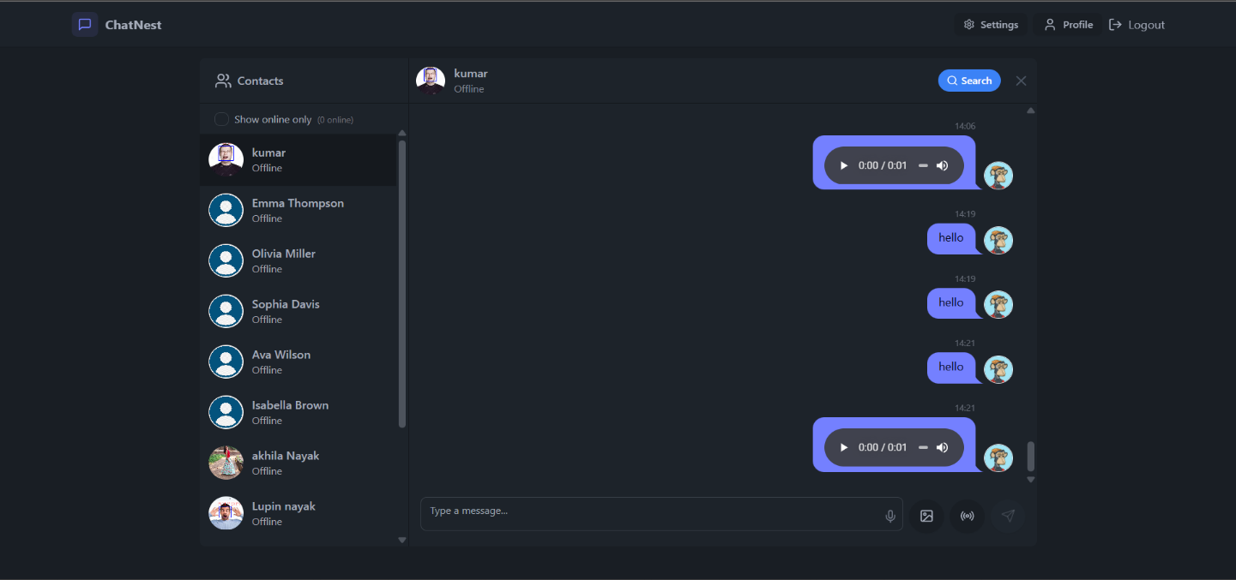

- Login page code:
import React, { useState } from 'react'
import { useAuthStore } from '../store/useAuthStore'
import { Loader2, MessageSquare, Mail, EyeOff, Eye, Lock } from 'lucide-react'
import { Link } from 'react-router-dom'

const LoginPage = () => {
const [showPassword, setShowPassword] = useState(false)
const [formData, setFormData] = useState({
email: "",
password: "",
})
const { login, isLoggingIn } = useAuthStore()
const handleSubmit = async (e) => {
e.preventDefault()
login(formData)
}
return (
<div className="h-screen flex items-center justify-center bg-base-100 p-4">
<div className="w-full max-w-md space-y-8">
<div className="text-center mb-8">
<div className="flex flex-col items-center gap-2 group">
<div className="w-12 h-12 rounded-xl bg-primary/10 flex items-center justify-center group-hover:bg-primary/20 transition-colors">
<MessageSquare className="w-6 h-6 text-primary" />
</div>
<h1 className="text-2xl font-bold mt-2">Welcome Back</h1>
<p className="text-base-content/60">Sign in to your account</p>
</div>
</div>
<form onSubmit={handleSubmit} className="space-y-6">
<div className="form-control">
<label className="label">
<span className="label-text font-medium">Email</span>
</label>
<div className="relative">
<div className="absolute inset-y-0 left-0 pl-3 flex items-center pointer-events-none">
<Mail className="h-5 w-5 text-base-content/40" />
</div>
<input
type="email"
className="input input-bordered w-full pl-10"
placeholder="you@gmail.com"
value={formData.email}
onChange={(e) => setFormData({ ...formData, email: e.target.value })}
/>
</div>
</div>
<div className="form-control">
<label className="label">
<span className="label-text font-medium">Password</span>
</label>
<div className="relative">
<div className="absolute inset-y-0 left-0 pl-3 flex items-center pointer-events-none">
<Lock className="h-5 w-5 text-base-content/40" />
</div>
<input
type={showPassword ? "text" : "password"}
className="input input-bordered w-full pl-10"
placeholder="Password"
value={formData.password}
onChange={(e) => setFormData({ ...formData, password: e.target.value })}
/>
<button
type="button"
className="absolute inset-y-0 right-0 pr-3 flex items-center"
onClick={() => setShowPassword(!showPassword)}
>
{showPassword ? (
<EyeOff className="h-5 w-5 text-base-content/40" />
) : (
<Eye className="h-5 w-5 text-base-content/40" />
)}
</button>
</div>
</div>
<button type="submit" className="btn btn-primary w-full" disabled={isLoggingIn}>
{isLoggingIn ? (
<>
<Loader2 className="h-5 w-5 animate-spin" />
</>
) : (
"Sign In"
)}
</button>
</form>
<div className="text-center">
<p className="text-base-content/60">
Don't have an account?{" "}
<Link to="/signup" className="link link-primary">
Create account
</Link>
</p>
</div>
</div>
</div>
)
}export default LoginPage
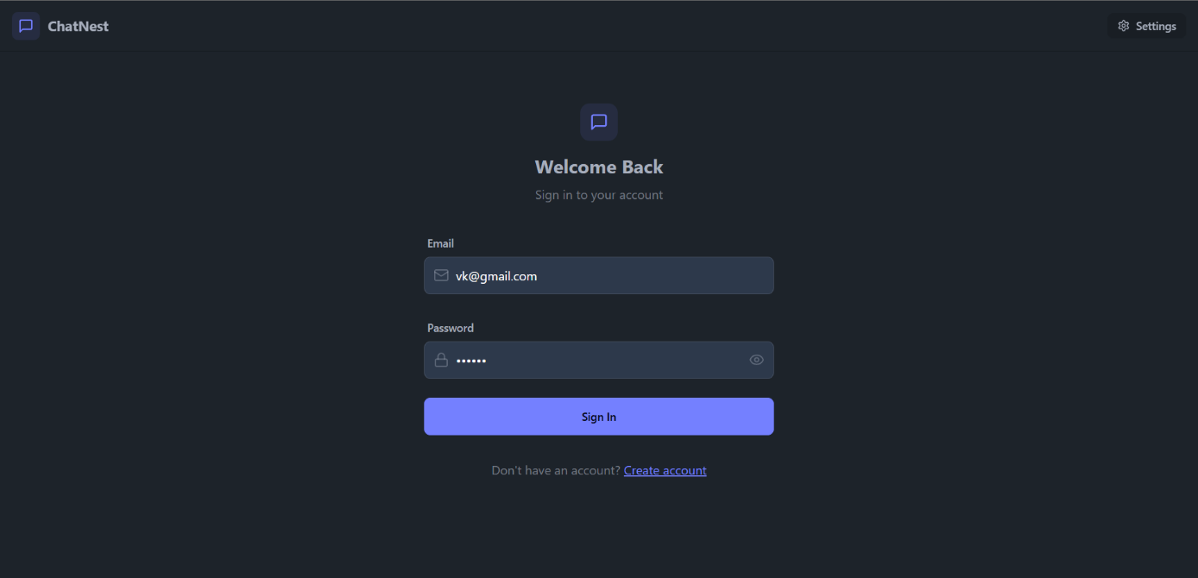

- Profile page code:
import { useState } from 'react'
import { useAuthStore } from '../store/useAuthStore'
import { Camera, User, Mail } from "lucide-react"

const ProfilePage = () => {
const { authUser, isUpdatingProfile, updateProfile } = useAuthStore()
const [selectedImg, setSelectedImg] = useState(null)
const handleImageUpload = async (e) => {
const file = e.target.files[0]
if (!file) return

const reader = new FileReader()
reader.readAsDataURL(file)

reader.onload = async () => {
const base64Image = reader.result
setSelectedImg(base64Image)
await updateProfile({ profilepic: base64Image })
}
}
return (
<div>
<div className="h-screen pt-20">
<div className="mx-auto max-w-2xl p-4 py-8">
<div className="text-center">
<h1 className='text-2xl font-semibold'>Profile</h1>
<p className='mt-2'>Your profile information</p>
</div>

<div className="flex flex-col items-center gap-4">
<div className="relative">
<img
src={selectedImg || authUser.profilepic || "/avatar.png"}
alt="profile"
className='size-32 rounded-full object-cover border-4'
/>
<label
htmlFor="avatar-upload"
className={`absolute bottom-0 right-0 bg-base-content
hover:scale-105 p-2 rounded-full cursor-pointer transition-all duration-200
${isUpdatingProfile ? "animate-pulse pointer-events-none" : ""}`}
>
<Camera className="w-5 h-5 text-base-200" />
<input type="file"
id='avatar-upload'
className='hidden'
accept='image/*'
onChange={handleImageUpload}
disabled={isUpdatingProfile}
/>
</label>
</div>
<p className='text-sm text-zinc-400'>{isUpdatingProfile ? "Uploading..." : "Click the camera icon to update your photo"}</p>
</div>

<div className="space-y-6">
<div className="space-y-15">
<div className="flex items-center gap-2 text-sm text-zinc-400">
<User className="w-4 h-4" />
Full Name
</div>
<p className="border px-4 py-2.5 bg-base-200 rounded-lg">{authUser?.fullname}</p>
</div>

<div className="space-y-1 5">
<div className="text-sm text-zinc-400 flex items-center gap-2">
<Mail className="w-4 h-4" />
Email Address
</div>
<p className="border px-4 py-2.5 bg-base-200 rounded-lg">{authUser?.email}</p>
</div>
</div>

<div className="mt-6 bg-base-300 rounded-lg p-6">
<h2 className="text-lg font-medium mb-4">Account Information</h2>
<div className="space-y-3 text-sm">
<div className="flex items-center justify-between py-2 border-b border-zinc-700">
<span>Member Since</span>
<span>{authUser.createdAt?.split("T")[0]}</span>
</div>
<div className="flex items-center justify-between py-2 ">
<span>Account Status</span>
<span className="text-green-500">Active </span>
</div>
</div>

</div>
</div>
</div>
</div >
)
}
export default ProfilePage
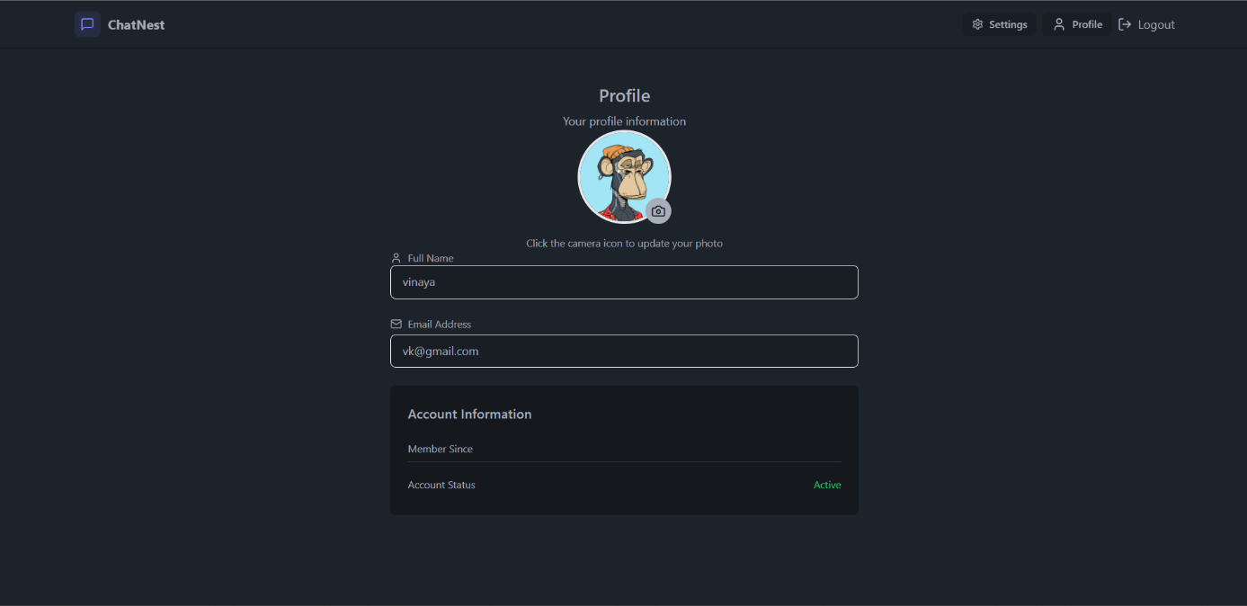
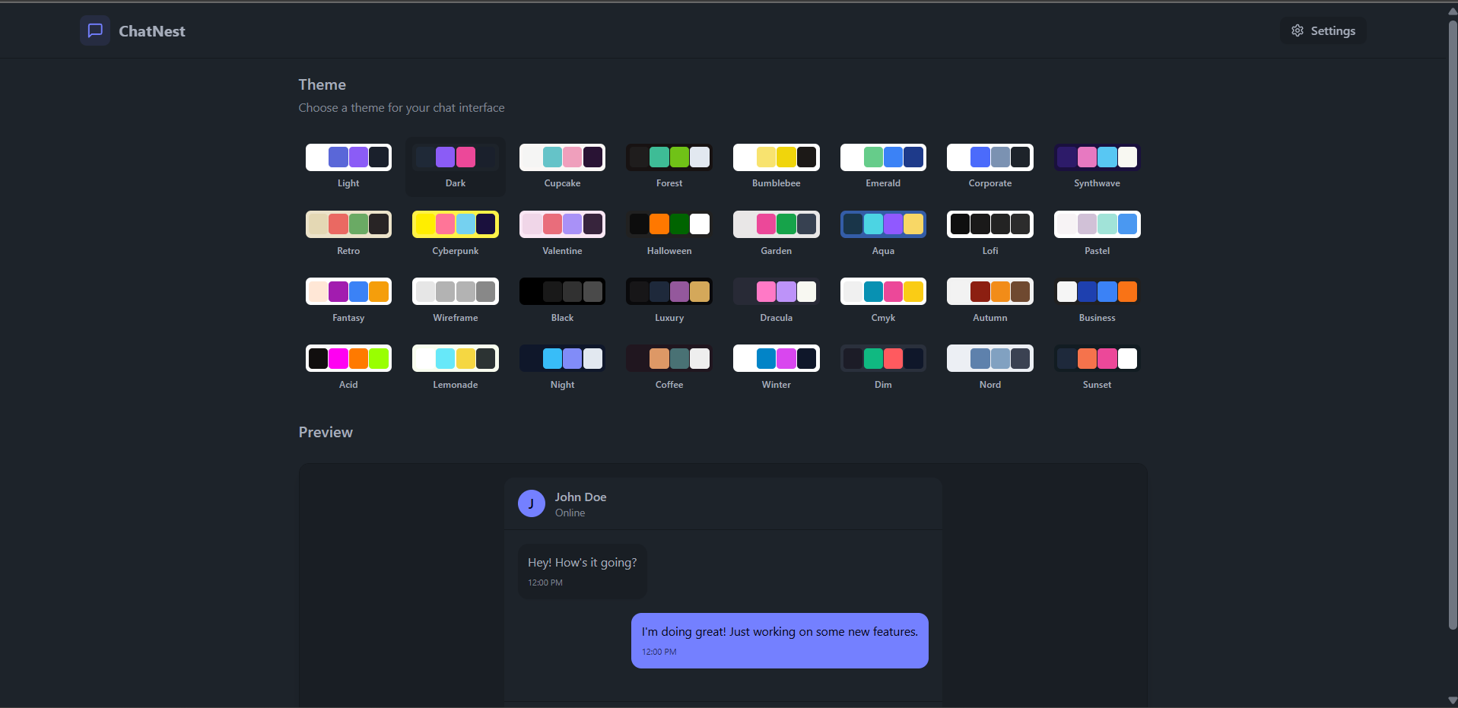

- Signup page code:
import { MessageSquare, User, Mail, Eye, EyeOff, Lock, Loader2 } from 'lucide-react';
import { useState } from 'react'
import { useAuthStore } from '../store/useAuthStore'
import { Link } from 'react-router-dom'
import AuthImagePattern from '../components/AuthImagePattern'
import toast from 'react-hot-toast';

const SignUpPage = () => {
const [showPassword, setShowPassword] = useState(false)
const [formData, setFormData] = useState({
fullname: "",
email: "",
password: "",
})

const { signup, isSigningup } = useAuthStore()

const validateForm = () => {
if (!formData.fullname.trim()) return toast.error("FullName is required")
if (!formData.email.trim()) return toast.error("Email is required")
if (!/\S+@\S+\.\S+/.test(formData.email)) return toast.error("Invalid Email format")
if (!formData.password) return toast.error("Password is required")
if (formData.password.length < 6) return toast.error("Password must be atleast 6 characters")

return true
}
const handleSubmit = (e) => {
e.preventDefault()

const success = validateForm()

if (success === true) signup(formData)
}
return (
<div className='min-h-screen grid lg:grid-cols-2'>
<div className='flex flex-col justify-center items-center p-6 sm:p-12'>
<div className='w-full max-w-md space-y-8'>
<div className='text-center mb-8'>
<div className='flex flex-col items-center gap-2 group'>
<div className='size-12 rounded-xl bg-primary/10 flex items-center justify-center group-hover:bg-primary/20 transition-colors'>
<MessageSquare className='size-6 text-primary' />
</div>
<h1 className='text-2xl font-bold mt-2'>Create Account</h1>
<p className='text-base-content/60'>Get start with your free account</p>
</div>
</div>

<form onSubmit={handleSubmit} className='space-y-6'>
<div className='form-control'>
<label className='label'>
<span className='label-text font-medium'>Full Name</span>
</label>
<div className='relative'>
<div className='absolute inset-y-0 left-0 pl-3 flex items-center pointer-events-none'>
<User className="size-5 text-base-content/40" />
</div>
<input type="text"
className={`input input-bordered w-full pl-10`}
placeholder="Enter your Full name"
value={formData.fullname}
onChange={(e) => setFormData({ ...formData, fullname: e.target.value })}
/>
</div>
</div>

<div className='form-control'>
<label className='label'>
<span className='label-text font-medium'>
Email
</span>
</label>
<div className='relative'>
<div className='absolute inset-y-0 left-0 pl-3 flex items-center pointer-events-none'>
<Mail className="size-5 text-base-content/40"></Mail>
</div>
<input type="text"
className={`input input-bordered w-full pl-10`}
placeholder='Enter you gmail'
value={formData.email}
onChange={(e) => setFormData({ ...formData, email: e.target.value })}
/>
</div>
</div>

<div className='form-control'>
<label className='label'>
<span className='label-text font-medium'>Password</span>
</label>
<div className='relative'>
<div className='absolute inset-y-0 left-0 pl-3 flex items-center pointer-events-none'>
<Lock className="size-5 text-base-content/40"></Lock>
</div>
<input type={showPassword ? "text" : "password"}
className='input input-bordered w-full pl-10'
placeholder='Password'
value={formData.password}
onChange={(e) => setFormData({ ...formData, password: e.target.value })} />

<button
type='button'
className='absolute inset-y-0 right-0 pr-3 flex items-center' onClick={() => setShowPassword(!showPassword)}>
{showPassword ? (
<EyeOff className='size-5 text-base-content/40' />
) : (
<Eye className='size-5 text-base-content/40' />
)}
</button>export default SignUpPage

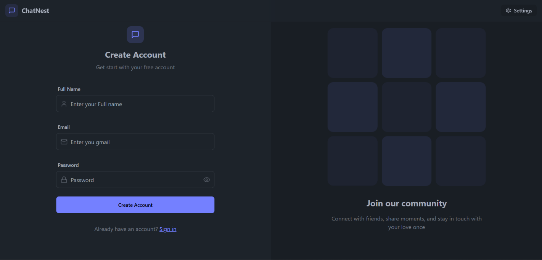

5.5 Integration of Encryption and Authentication:
import crypto from "crypto";
const algorithm = "aes-256-cbc";
const secretKey = process.env.MESSAGE_SECRET || "default_secret_key_32bytes";
// Must be 32 bytes (256-bit) for AES-256
const ivLength = 16;

export function encrypt(text) {
if (!text) return text;
const iv = crypto.randomBytes(ivLength);
const cipher = crypto.createCipheriv(
algorithm,
Buffer.from(secretKey, "hex"), // ✅ Use hex key from .env
iv
);
let encrypted = cipher.update(text, "utf-8", "hex");
encrypted += cipher.final("hex");
return iv.toString("hex") + ":" + encrypted;
}

export function decrypt(encryptedText) {
if (!encryptedText) return encryptedText;
try {
const [ivHex, encrypted] = encryptedText.split(":");
const iv = Buffer.from(ivHex, "hex");
const decipher = crypto.createDecipheriv(
algorithm,
Buffer.from(secretKey, "hex"), // ✅ Use same hex key
iv
);
let decrypted = decipher.update(encrypted, "hex", "utf-8");
decrypted += decipher.final("utf-8");
return decrypted;
} catch (err) {
return encryptedText; // fallback if something goes wrong
}
}

5.6 Implementation of Voice Typing and Audio Recorder:
- Audio route code:
// routes/audio.route.js
import express from "express";
import { uploadAudio } from "../controllers/audio.controller.js";
import { protectRoute } from "../middleware/auth.middleware.js";
const router = express.Router();
router.post("/upload", protectRoute, uploadAudio);
export default router;

- Audio controller code:
// controllers/audio.controller.js
import { v2 as cloudinary } from "cloudinary";
import Message from "../models/message.model.js";

// ✅ configure cloudinary (if not already)
cloudinary.config({
cloud_name: process.env.CLOUDINARY_CLOUD_NAME,
api_key: process.env.CLOUDINARY_API_KEY,
api_secret: process.env.CLOUDINARY_API_SECRET,
});

export const uploadAudio = async (req, res) => {
try {
const { audioData, receiverId } = req.body;
const senderId = req.user._id;

if (!audioData || !receiverId) {
return res.status(400).json({ message: "Audio data or receiver missing" });
}

// Upload to Cloudinary
const uploadRes = await cloudinary.uploader.upload(audioData, {
resource_type: "video", // audio treated as video in Cloudinary
folder: "voice_messages",
});

const newMsg = new Message({
senderId,
receiverId,
fileUrl: uploadRes.secure_url,
fileType: "audio",
fileName: "voice_message",
});
await newMsg.save();
res.status(201).json(newMsg);
} catch (err) {
console.error(err);
res.status(500).json({ message: "Audio upload failed" });
}
};
5.7 Implementation of File Sharing:
- It manages the upload of images, videos, and documents to the server.
- Metadata is saved in MongoDB while actual files remain safely stored.
- Images and videos are shown inside the chat, not as plain downloads.
- Only allowed formats and safe sizes are processed.
- Users experience minimal delay while sharing files.

5.8 Online User Tracking Logic:
- Each time a user connects, their status updates automatically.
- This map helps identify which users are currently online.
- When someone comes online or goes offline, other users are updated instantly.
- A green dot for online, grey for offline gives clear visual cues.
- Users know exactly when someone is available to chat.

5.10 Summary:
This chapter described how each part of ChatNest was developed From backend APIs to real-time communication, every module was implemented step-by-step. MERN stack technologies were integrated effectively through MongoDB, Express, React, Node, and Socket.io worked together to create a smooth experience and Security and multimedia capabilities were fully implemented through Encryption, authentication, file sharing, and voice features all contribute to the app’s richness.
Real-time logic powers instant interaction can be done by Socket.io which ensures messages and online statuses appear instantly and the foundation for a fully functional chat system is complete.

RESULTS AND TESTING
6.1 Introduction:
- The purpose of this chapter is to present how well the ChatNest system performs under different conditions and how effectively it responds to real-time interactions.
- This section highlights the practical outcomes of the application after implementation, showing what works, how it behaves, and how smooth the user experience is.
- The results focus on message delivery speed, accuracy of voice typing, reliability of file sharing, and overall interaction between users.
- Testing was carried out to ensure that the system remains stable even when multiple users are active at the same time.
- This chapter also includes comparisons, screenshots, and observations that help reflect the real-world usability of ChatNest.
6.2 Test Cases and Scenarios:
- Real-time Message Delivery Test: Messages were sent between two accounts to verify if they appear instantly without delays. The system consistently delivered messages in real-time, confirming stable Socket.io integration.
- User Authentication Test: Login and registration were tested using valid and invalid inputs. The system correctly handled errors, such as wrong passwords or duplicate email IDs.
- File Sharing Test: Images, MP4 videos, and documents of different sizes were uploaded to check upload speed, format compatibility, and database storage. The files were successfully delivered across chats.
- Voice Typing and Audio Recording Test: Multiple voice samples were recorded in quiet and noisy environments. The speech-to-text conversion remained reasonably accurate in all conditions.
- Online User Tracking Test: The system was tested with multiple browser sessions to verify that the “online” status updates the moment a user logs in or logs out.
- Search Functionality Test: Text messages, images, and audio files were searched using keywords. The application returned accurate and relevant search results consistently.

6.3 Performance Evaluation:
- Speed and Responsiveness: ChatNest responds quickly to user actions. Real-time features such as message delivery and status updates work smoothly without noticeable lag.
- Server Load Handling: During stress testing with multiple simulated users, the backend server handled concurrent socket connections effectively without crashing.
- Database Query Efficiency: MongoDB responded well to frequent insert and fetch operations, especially when loading chat history or searching for messages.
- Media Upload Performance: Uploading different media files did not slow down the chat. Even larger files were processed without freezing the UI.
- CPU and Memory Usage: The application maintained stable CPU and memory usage during extended chat sessions, proving that the system can support long-term interaction without performance dips.
- Voice Feature Responsiveness: The voice-to-text recognition and audio recording were smooth, and the recorded audio played back instantly within the conversation.
6.5 Comparison with Existing Systems:
- Compared to basic chat applications, ChatNest provides a more complete experience by supporting real-time messaging along with voice typing, media sharing, and audio recording.
- Unlike traditional messaging apps that rely only on HTTP requests, ChatNest uses Socket.io, making its communication faster and more interactive.
- Many existing academic chat projects do not offer features like dark mode, online status detection, or encryption. ChatNest stands out by including these as core functionalities.
- ChatNest provides an integrated search system for text, images, and audio, whereas many standard apps only support plain text search.
- The application maintains a more user-friendly design, giving users flexibility in customizing themes and switching between light and dark modes.

SUMMARY:
ChatNest is a real-time chat application built with the MERN stack that helps users communicate instantly and securely. It supports features like text messaging, voice typing, audio recording, and file sharing (images, videos, PDFs). With Socket.io, users get live message updates, and the system also shows who is online in real time. ChatNest includes a message search option and lets users personalize their experience with different themes and dark/light mode. Overall, the project demonstrates how modern technologies like RESTful APIs, real-time sockets, and secure databases come together to create a smooth and interactive chat experience.

REFERENCE:
Documentation: Tailwindcss, Socket.io, Express, Daisy UI, React
AI tools: ChatGPT, Claude, Gemini
YouTube: Codesistency

